Project Documentation

What are SDLC & its rules?

For project development rules & regulation

Need to be followed for best quality output at defined time limit

Rules are Software Development Life Cycle – SDLC

It‘s part of software engineering

Six rules to be followed…

1. Requirement Gathering / collection information

Budget

time

requirements

2. Analysis & SRS

Step 1) Define each module/user

Guest

Customer Website

Admin/Doctor Admin panel

Employee Employee panel

Step 2) Define each module/user task / activity / work

**Guest**

View categories

View services

View Blog

Contacts

**Customer**

View categories view

View services view

View Blog view

Contacts form

Signup form

Login form

Service book form

View service view

Profile manage view

Logout

Admin/Doctor Admin panel

Login login

Manage categories add / update / delete view T / form F

Manage services add / update / delete view T / form F

Manage Blog add / update / delete view T / form F

Manage Emp add / update / delete view T / form F

View Contacts view T

Manage Customer view / lock /upd /del view T

Manage Service book view T

Profile manage view T

Logout

**Employee Employee panel**

Login login

Manage categories add / update / delete view T / form F

Manage services add / update / delete view T / form F

Manage Blog add / update / delete view T / form F

View Contacts view T

Manage Customer view / lock /upd /del view T

Manage Service book view T

Profile manage view T

Logout

Step 3) Define Database & tables

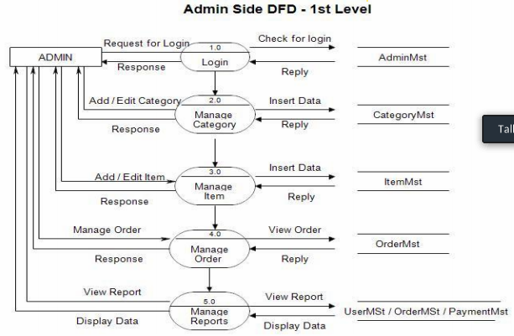

**Customer**

View categories categories.tbl

View services services.tbl

View Blog blog.tbl

Contacts contacts.tbl

**Customer** Signup customer.tbl

Login customer.tbl

Service book service_booking.tbl

View service service_booking.tbl

Profile manage customer.tbl

Logout customer.tbl

**Admin/Doctor Admin panel**

Login admin.tbl

Manage categories categories.tbl

Manage services services.tbl

Manage Blog blog.tbl

**Admin**  Manage Emp Emp.tbl

View Contacts contact.tbl

Manage Customer customer.tbl

Manage Service book services.tbl

Profile manage admin

Logout admin

Step 4) Define total Numbers of table

Admin

Customer

Employee

Categories

Services

Blog

Contact

Booking

Step 5) Define table column / Data dictionary

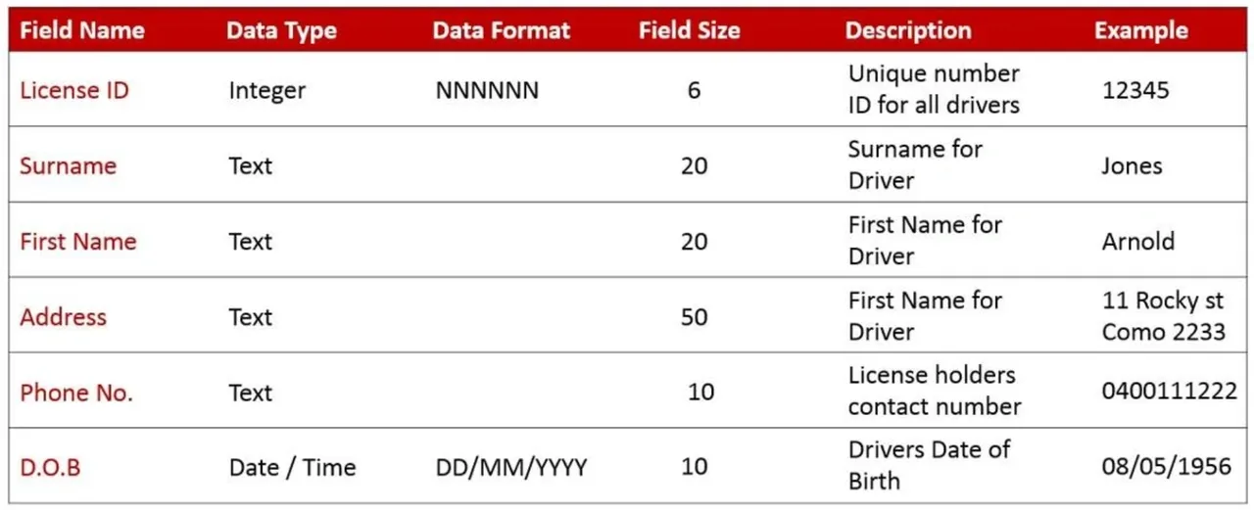

Admin

Customer signup form 5 / table 8

**Id**

Name

Email

Pass

Mobile

Photo

**Created_at**

**updated_at**

Employee

Categories

Services

Blog

Contact

Booking

3. Designing

Theme pages form submit / view => | tables Database table means data dictionary

4. Implementation (Coding)

Developer coding

5. Testing

Project testing & check that work without bugs & error

6. Maintenance

Installation / guide / changes service / maintenance